Hello copilot, I am here to use you to do a python project
Hey there! I'm excited to help you with your Python project 🐍💻
To get us rolling, could you tell me a bit more about what you're working on? Here are a few things that would help me help you:
- What is the project about? (e.g., web app, data analysis, automation, game, etc.)
- What’s your goal or end result? (e.g., a working script, a report, a dashboard)
- Do you already have some code or are we starting from scratch?
- Any specific tools or libraries you want to use? (e.g., Flask, Pandas, OpenCV)
Once I know that, we can dive right in and build something awesome together.
Lets write a program that makes a calculator to perform basic arithmetic
Awesome! Let's build a simple calculator in Python that can perform basic arithmetic operations: addition, subtraction, multiplication, and division. Here's a clean and beginner-friendly version:

🧮 Basic Arithmetic Calculator in Python
python
def add(x, y):
return x + y

def subtract(x, y):
return x - y

def multiply(x, y):
return x * y

def divide(x, y):
if y == 0:
return "Error: Cannot divide by zero"
return x / y

def calculator():
print("Welcome to the Python Calculator!")
print("Select operation:")
print("1. Add")
print("2. Subtract")
print("3. Multiply")
print("4. Divide")

choice = input("Enter choice (1/2/3/4): ")

if choice in ('1', '2', '3', '4'):
try:
num1 = float(input("Enter first number: "))
num2 = float(input("Enter second number: "))
except ValueError:
print("Invalid input. Please enter numeric values.")
return

if choice == '1':
print(f"{num1} + {num2} = {add(num1, num2)}")
elif choice == '2':
print(f"{num1} - {num2} = {subtract(num1, num2)}")
elif choice == '3':
print(f"{num1} * {num2} = {multiply(num1, num2)}")
elif choice == '4':
print(f"{num1} / {num2} = {divide(num1, num2)}")
else:
print("Invalid choice. Please select from 1 to 4.")

# Run the calculator
calculator()

✅ Features:
- Handles invalid input gracefully
- Prevents division by zero
- Easy to expand with more operations later
Would you like to turn this into a GUI app, add more advanced functions (like exponentiation or square roots), or make it reusable as a module?
This is basic work. Thank you
You're very welcome! 😊 If you ever want to level it up—like adding a graphical interface with Tkinter, making it voice-controlled, or turning it into a web app—I’m totally here for it.
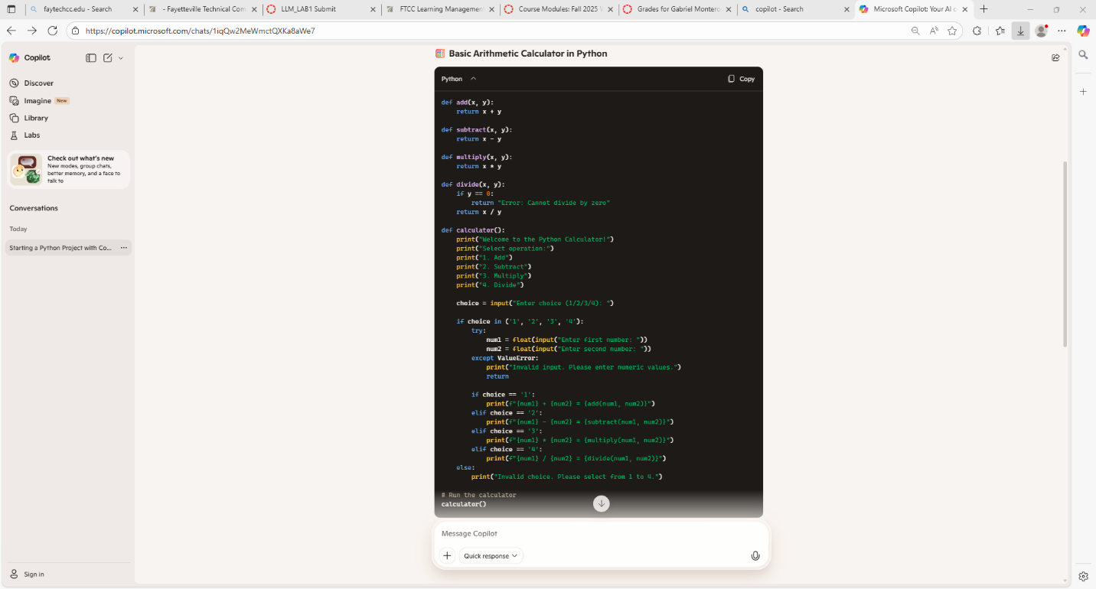

Reflection on the experience on using AI

When asking copilot to generate code I just asked it to build a simple calculator that, the one generate does simple addition, subtraction, multiplication, and division. When I copied and pasted it into visual studio code, it was formatted correctly and ran smoothly. There wasn’t a need for fixes or improvement since all I asked was for it to create a basic code rather than a complex one. Maybe in the future I would ask it to generate code if I wanted it to go from a basic calculator to a scientific calculator or a graphing calculator. I personally liked how fast and easy it generated the code and the benefit was a successful simple code, but I personally didn’t learn anything new on how to create a calculator. Maybe I should ask it to write comments so I can save the code as it comments teel me how the code works.

